**DOVZHENKO, Alexander (ДОВЖЕНКО, Олександер Петрович)** (1894–1956)

Ukrainian film director, artist and writer. He was born in Sosnytsia (Chernihiv region) and graduated from the Hlukhiv teachers’ college in 1914. He continued his studies at the Ukrainian State Academy of Arts in Kyiv (1917–19) and in Berlin, where he worked in the Ukrainian consulate (1922–23). Dovzhenko began his career as a cartoonist for the newspaper *Visti VUTsVK* in Kharkiv but switched to cinema in 1926. He wrote screenplays and directed films for the VUFKU (All-Ukrainian Photo Cinema Administration) studios in Odessa (1926–28) and Kyiv (1929–32). To avoid being persecuted as a Ukrainian “nationalist” during Stalin’s terror, Dovzhenko fled to Moscow in 1932, where he continued working at the Mosfilm studio for the rest of his life.

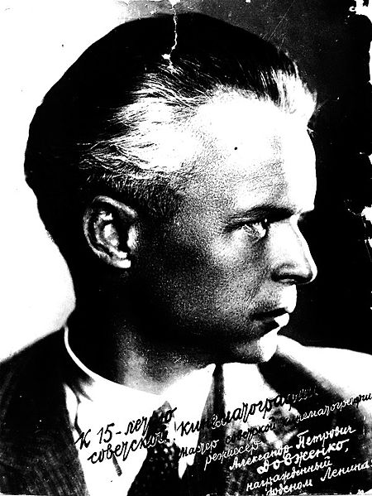

Dovzhenko learned the filmmaker’s craft directing two short comedies and a feature-length film titled *Sumka dypkur’iera* (The Diplomatic Pouch, 1927), a spy thriller. *Zvenyhora* (1927), an epic tale hailed by critics as the founding work of Ukrainian national cinema, established his reputation in Ukraine. The formal complexity and strong pacifist message of *Arsenal* (1929) brought Dovzhenko recognition in European avant-garde circles. *Zemlia* (Earth, 1930), whose subject was the transition to collectivized agriculture, became Dovzhenko’s best-known work and cemented his international reputation as the “poet of cinema.” Dovzhenko’s silent films were criticized in the Soviet Union for their “nationalist deviations” but received praise abroad, especially in Western Europe. His final film in Ukraine, *Ivan* (1932), marks transition to sound in Ukrainian cinema.

In Moscow, Dovzhenko was allowed to make only three feature films, *Aerograd* (1935), *Shchors* (1939), and *Michurin* (1948), and completed two documentaries during World War II: *Bytva za nashu Radians’ku Ukraïnu* (The Battle for Our Soviet Ukraine, 1943) and *Peremoha na Pravoberezhnii Ukraïni* (Victory in Right-Bank Ukraine, 1945). Forbidden from making films, Dovzhenko turned to literature where he challenged the doctrine of Socialist Realism. He is best known for short stories, including “Maty” (Mother) and “Pered boiem” (Before the Battle); and the “cine-novels,” including *Zacharovana Desna* (The Enchanted Desna, 1954).

Dovzhenko’s film style, falsely labelled as “realist” by Soviet critics, still awaits a thorough study. At first glance it encompasses elements of two main avant-garde movements of the 1920s, German Expressionism and Soviet Montage. Under closer scrutiny Dovzhenko’s works reflect the “away from Moscow” orientation of the Ukrainian arts of the 1920s promulgated by Modernist groups such as Vaplite, which he helped found. They strived to match the traditions of quality in Western art with native and folk traditions of Ukraine. Dovzhenko’s mise-en-scene combines Neo-Byzantine Monumentalism, Expressionism, Cubism and visual paradoxes reminiscent of Surrealist art. His editing aims at a unifying, rhythmical structure often based on Ukrainian folk songs. Although his films have simple plot lines, they offer rich philosophical reflections on the nature of war and revolution (*Arsenal*), history and culture (*Zvenyhora*) and life and death (*Earth*).

**References and Further Reading**

Dovzhenko, Alexander (1973). *The Poet as Filmmaker: Selected Writings*. Ed. and transl. Marco Carynnyk, Cambridge, MA: MIT Press.

Kepley, Vance, Jr. (1986). *In the Service of the State: The Cinema of Alexander Dovzhenko*. Madison, WI: University of Wisconsin Press.

Kutsenko, Mykola (1975). *Storinky zhyttia i tvorchosti O. P. Dovzhenka*. Kyiv: Dnipro.

Liber, George O. (2002). *Alexander Dovzhenko: A Life in Soviet Film*. London: BFI.

Nebesio, Bohdan Y., ed. (1994). *The Cinema of Alexander Dovzhenko*, special issue *Journal of Ukrainian Studies* 19 (1).

Nebesio, Bohdan Y. (1995) *Alexander Dovzhenko: A Guide to Published Sources.* Edmonton: CIUS Press.

Trymbach, Serhii (2007). *Oleksandr Dovzhenko: Zahybel Bohiv, identyfikatsiia avtora v natsionalnomu chaso-prostori.* Vinnytsia: Hlobus Pres.

Uzwyshyn, Ray. “Alexander Dovzhenko’s Silent Trilogy: A Visual Exploration,” http://rayuzwyshyn.net/dovzhenko/dovzhenkostudy.html

Zolotoverkhova, I. and Konovalov, H. (1968) *Dovzhenko-khudozhnyk*. Kyiv: Mystetstvo.

**Bohdan Y. Nebesio, Brock University**